# Les 2 – Storyboarding

Screenplayed.com



* Goede site voor scripts te lezen

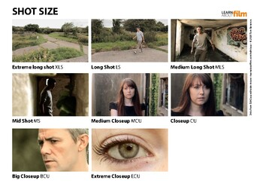

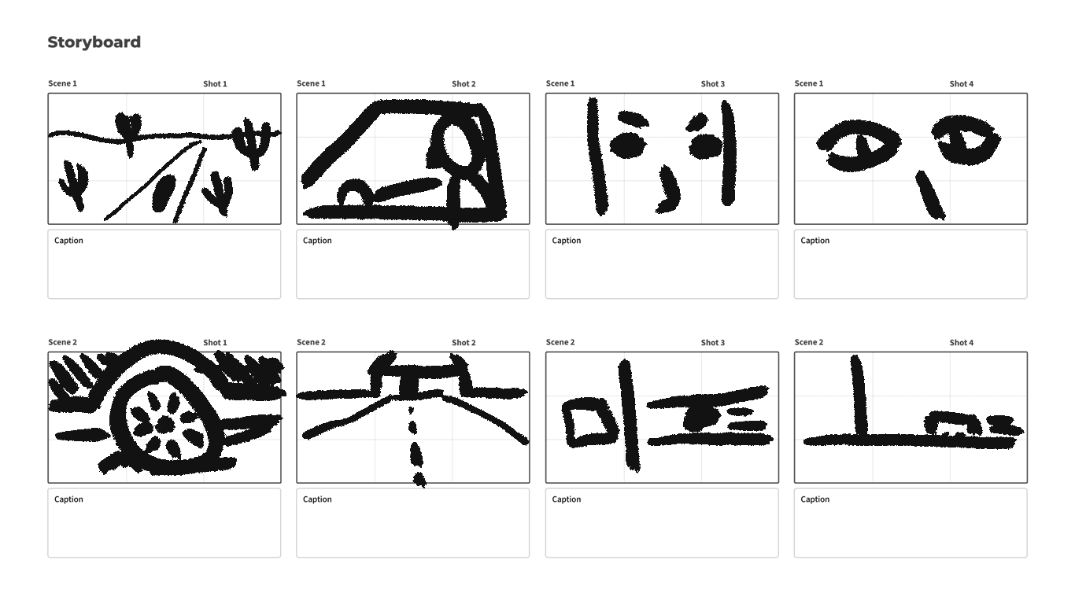

# The green mile:

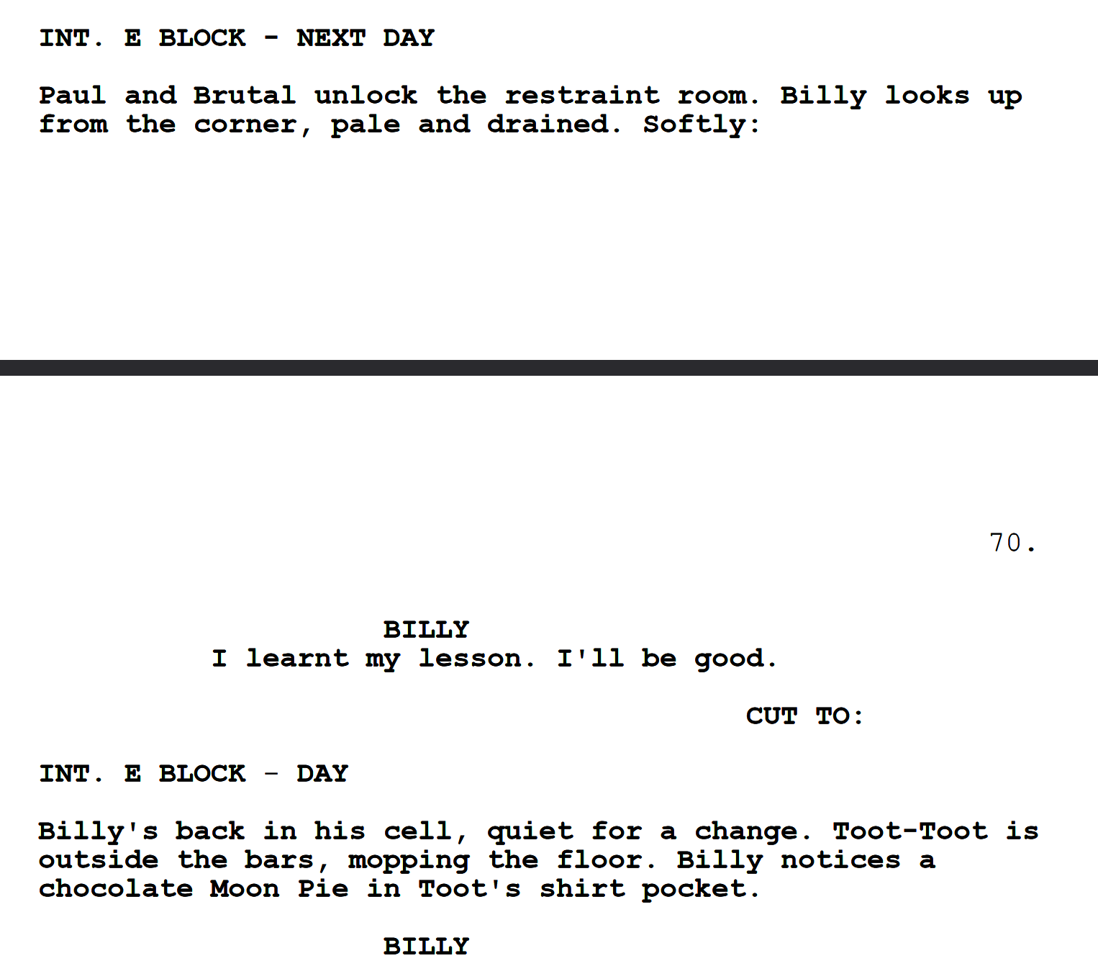

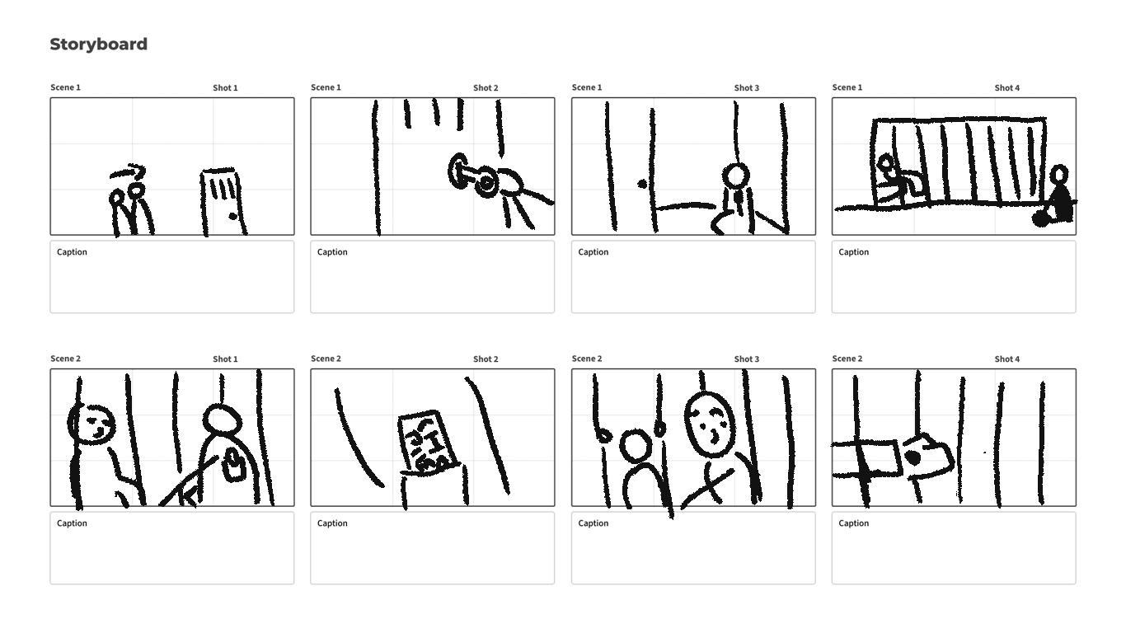

## Star wars V

